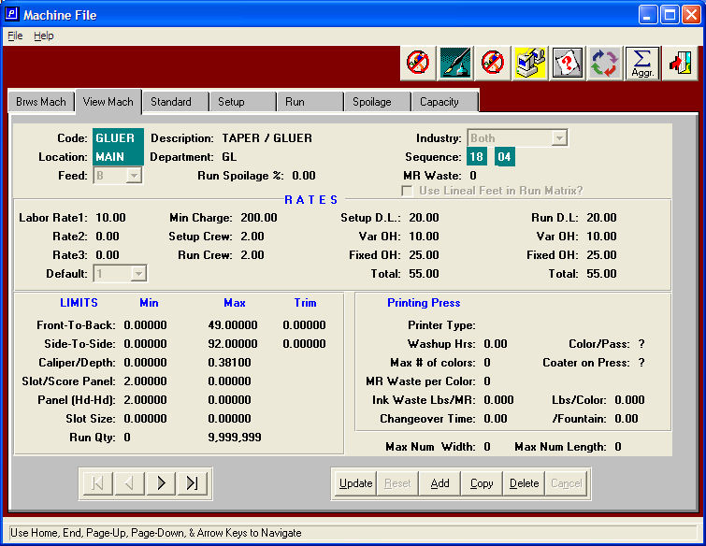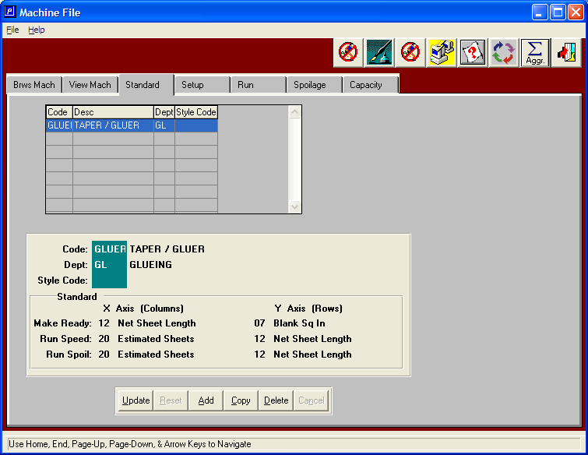
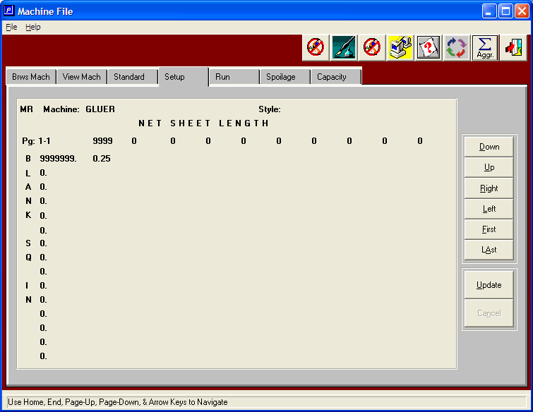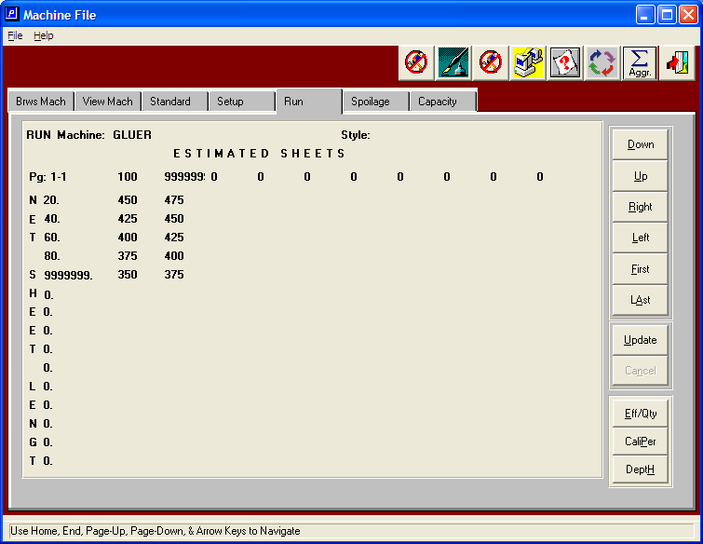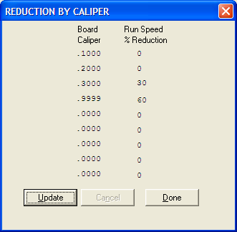

The Reduction by Caliper adjusts the run speed for micro flutes, single wall, double wall and triple wall.
E and F flutes are under .1000 thickness, A, B and C flutes are under .2000 caliber, double wall is less than .3000 and triple wall, which is approximately .3500 would fall under .40000 which is defined as .9999 thickness. If your company runs foam, then change triple wall to .4000 and add additional caliper thickness for foam dimensions such as 1 inch, 2 inch, etc.
